Mobile application to support nurses’ workflow

**Bachelor project**

***Session 2015***

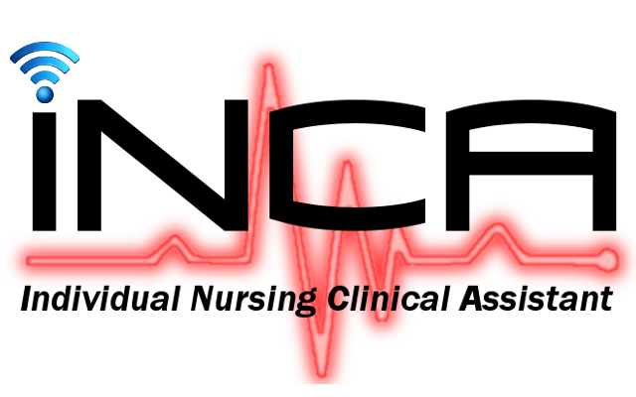

**Graduate :** Argentin Yvann

**Internal handler :** Florent Glück

**External expert :** Frédéric Ehrler

**Major :** logiciels et systèmes complexe

**Foreword**

Document’s structure

This thesis was developed with the help of the **Universitary Hospital of Geneva** (**HUG**).

This thesis will start by a context description, what was the initial issue, how it was solved up until now and why a better solution was needed. It will also explain how the current informatics architecture of the **HUG** works.

It will then explain what technologies will be used to reach the overall goal and describe the new nurses workflow. This first part will end by the description of all the restrictions and issues working in a distant place with sensitive data imply and what were the main challenges coming along with it.

The second part will be an in depth description of all the technologies and protocols I’ve used. How they work alone and together to produce a “native app” on both **Android** and **IOS.**

The third part of this thesis will describe the application in itself; it will contain a lot of illustrations and schemas to help understanding exactly what everything does. It will also describe in detail how the **HUG** data are structured and how I accessed, manipulated and displayed them to ensure the best user experience (**UI**).

It will then end with the possible enhancing mostly in terms of user experience (**UX**).  
It will talk about the issues and problems encountered during the creation process and finish with the conclusions drawn out of the entire project.

Text formatting/Manual of style

To allow an easier understanding and readability of the document some text formatting rules will be applied:

* Names, acronyms and company names will be in **bold**.
* Important words will be in *italic*.
* References to code and/or file/folder will be between [**brackets in bold**]

Special thanks

I would like to start by thanking **Mr. Glück Florent** for his guidance and help during the entire thesis.

I would also like to thank **Mr. Ehrler Frédéric** for his availability, help and advices, as he was my main source of information for the entire **HUG** related questions. He also provided me with a desk within the **HUG** mainframe.

# Chapter 1

# Introduction

## Initial problem

## Hospital architecture

## Solution proposed

### Existing app

### Requirements

### Technologies

### New nurses workflow

## Restrictions

## Challenges

# Framework

## AngularJS

## Ionic

## Plugins / Modules

## IBeacon

## OAuth

# Application

## Navigation and architecture

## Wireframes and functionalities

## Hospital data structure

## Sensitive patient data handling

## Data transmission

# Conclusion

## Possible enhancing

## Problems and challenges

## Conclusions

# References

# Annex